**Interview questions**

Networking:

1.What is Load balancer?

## Load balancing is the practice of distributing computational workloads between two or more computers. On the Internet, load balancing is often employed to divide network traffic among several servers. This reduces the strain on each server and makes the servers more efficient, speeding up [performance](https://www.cloudflare.com/learning/performance/why-site-speed-matters/) and reducing [latency](https://www.cloudflare.com/learning/performance/glossary/what-is-latency/). Load balancing is essential for most Internet applications to function properly.

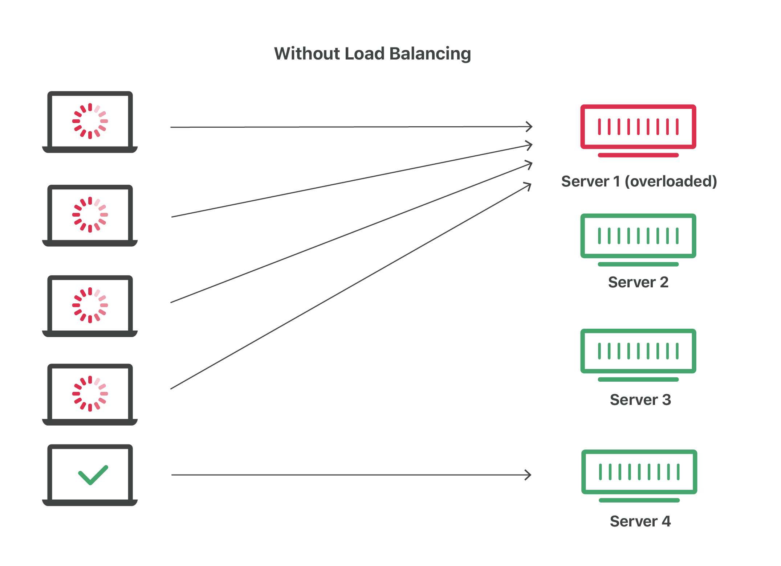

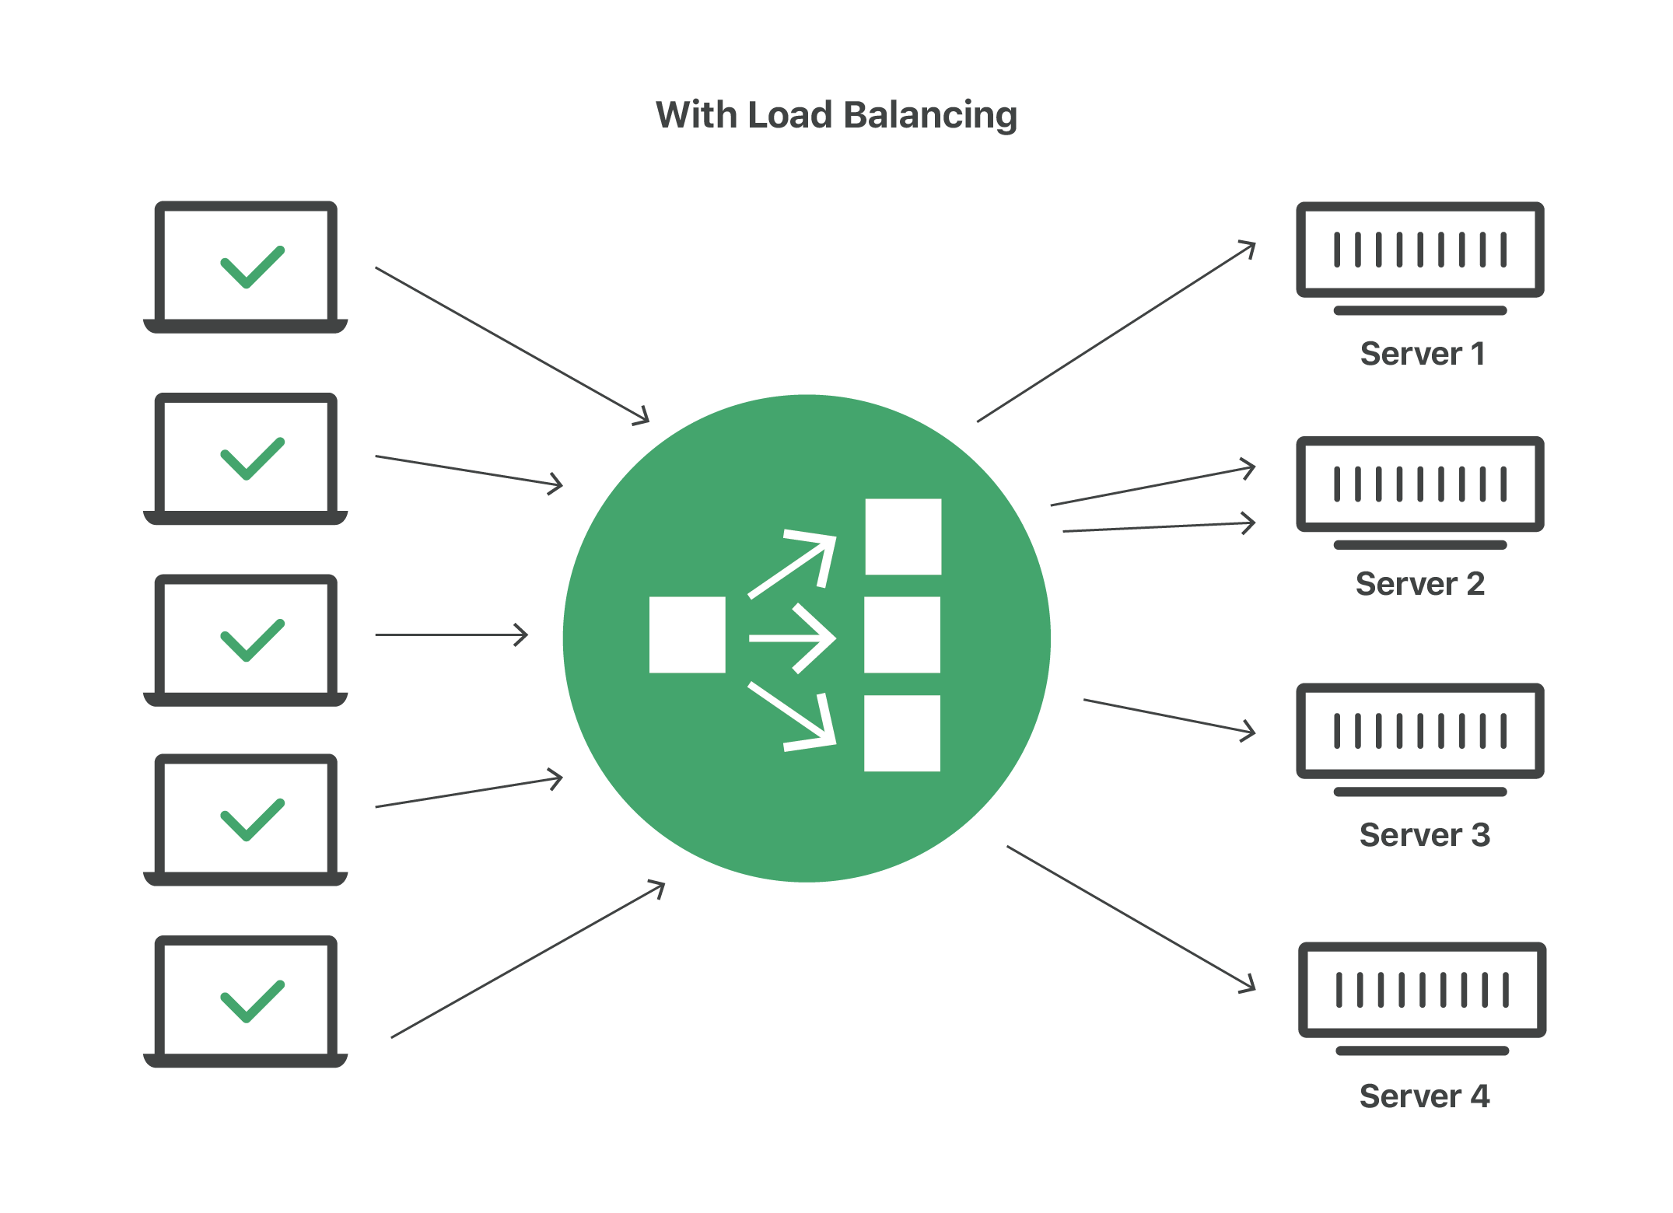

2. Types of Load balancer?

# 1.Application Load Balancer: The **Application Load Balancer** is a feature of Elastic **Load Balancing** that allows a developer to configure and route incoming end-user traffic to **applications** based in the AWS public cloud. In a cloud environment with multiple web services, **load balancing** is essential.

# 2.Network Load Balancer: The **Network Load** Balancing (**NLB**) feature distributes **traffic** across several servers by using the TCP/IP **networking** protocol. By combining two or more computers that are running applications into a single virtual cluster, **NLB** provides reliability and performance for web servers and other mission-critical servers.

# 3.Classic Load Balancer: **Classic Load Balancer** provides basic **load** balancing across multiple Amazon EC2 instances and operates at both the request level and connection level. **Classic Load Balancer** is intended for applications that are built within the EC2-**Classic** network.

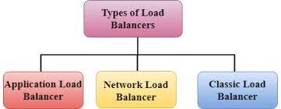

3.what is application gateway?

# An application gateway is a program that serves as a firewall proxy. It runs between computers in a network to tighten security. It is responsible for filtering incoming traffic that contains network application data.

# It provides an additional layer of protection against unwanted network traffic. It is also sometimes known as an “application-level gateway” or “application proxy.”

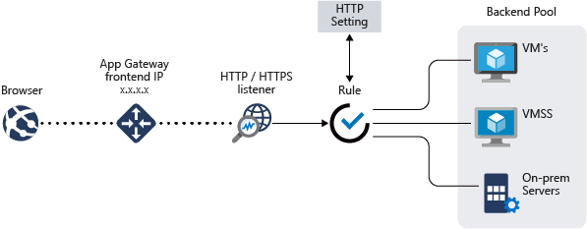

**4.Difference between Load balancer and Gateways?**

API Gateway provides a single entry point for a client for a number of different underlying APIs (system interfaces/web services/Rest APIs etc.)

Load Balancer provides facilitates load distribution for your application servers (where you may have deployed your microservice’s/Rest APIs)

**5.How do you configure IIS Webserver in your windows server? Why is it important**

To install Internet Information Services (IIS), follow the steps below:

1. Start > Control Panel > Programs and Features  
   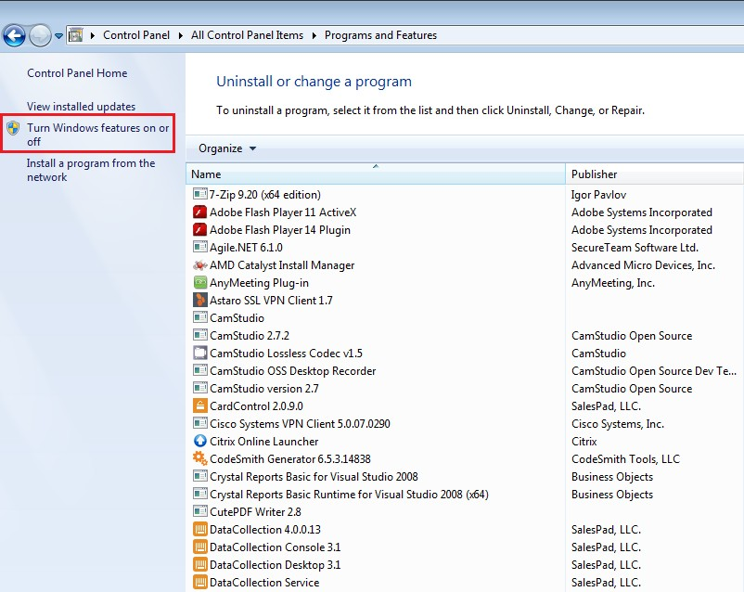
2. Click Turn Windows features on or off. The Windows Features window will appear.

3. Make sure all features under Internet Information Services and Microsoft .NET Framework are select

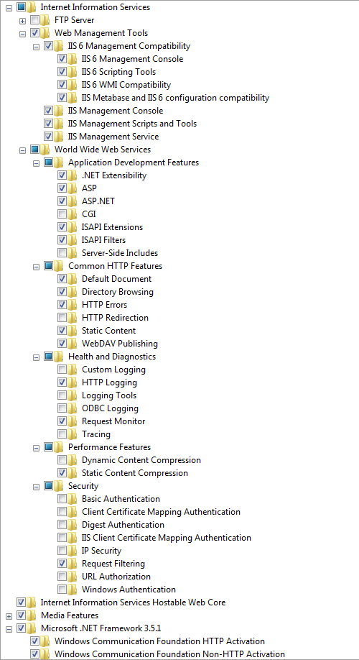

4.Click **OK**to install selected Windows components, including IIS.

5.To access IIS, click the Windows **Start**button. The Start menu/screen appears. Start typing internet information services manager in the search field and click the Internet Information Services (IIS) Manager once it appears.

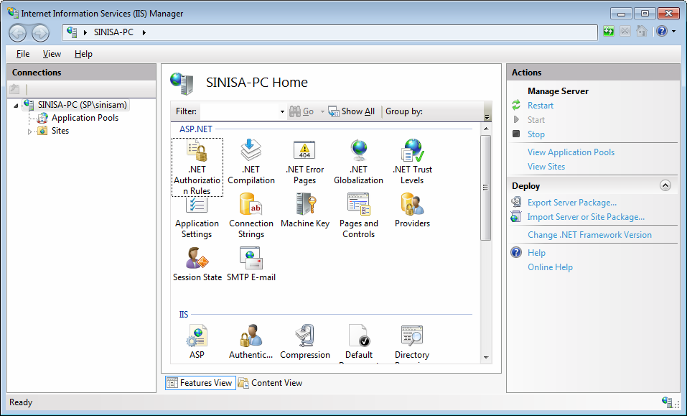

**6.What is public IP, private IP?**

A **Public IP address** (*External*) is assigned to every device that connects to the Internet and each IP address is unique. Therefore, there cannot exist two devices with the same public IP address. This addressing scheme makes it possible for the devices to “find each other” online and exchange information. A user has no control over the IP address (public) that is assigned to the device. The public IP address is assigned to the device by the Internet Service Provider as soon as the device is connected to the Internet. This is known to be wrong.

A public IP address can be **static**, **dynamic** or **shared**.

**Private IP address** (*Internal*) is only used by devices communicating to each other on the same network. Devices with private IP addresses cannot connect to the Internet directly. Likewise, computers or other devices outside the local network cannot connect directly to a device with a private IP.

## **IP Address Terminology**

**Static** means the IP address never changes as long as you stay with the same provider or same server.

**Dynamic** means the IP address can change from time-to-time.

**Public** means the IP address can be reached via the Internet from any computer in the world.

**Private** means the IP address can only be reached by other devices on the same network.

**Shared** means other people besides you use your IP address for their connection.

**Dedicated** means no one else uses your IP address for their connection.

**Class** identifies the range of your IP address and the default subnet mask. Examples of IP classes:

* *A class - 0 to 127 with default mask of 255.0.0.0*
* *B class - 128 to 191 with default mask of 255.255.0.0*
* *C class - 192 to 223 with default mask of 255.255.255.0*
* *D class - 224 to 247 (not currently used)*
* *E class - 248 to 255 (not currently used)*

7.What is vnet , subnet?